Intro to CS (2015-16) Name______________________Hr__
Unit 2.5: eBaySale.java FRIDAY, Dec 10, 2015

Joe Shmoe purchases a new radio-controlled vehicle from a seller on Ebay as a birthday present for his friend, Jim Bob. Upon receiving the vehicle, Joe discovers that his friend already owns this model. Joe then decides to sell the vehicle on Ebay himself for $10 more than he was charged. Since he is new to Ebay, Joe must setup an account and pay the current installation fee of $5.85. In addition, Ebay charges a 2% charge for each item sold (based upon the sale price).

Write a program that asks for the original price paid by Joe Shmoe for the vehicle. In either a field or in a message box, display the amount of profit Joe will make on this re-sale (if any), to the nearest penny. I have used a sales of $20 as a test case for you to see if your calculations are correct!

Your program should be turned into the 5th Hour Drop box in a project folder titled
Lastname eBay Sales
And inside it, will contain your package file as well as your .java file.

Be sure to include your name, program description, etc in the comment section at the beginning of your .java file!

Program requirements are on the back of this doc.

Your output windows should look like these:
GUI Frame (note title of window

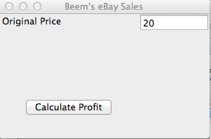

Message box with the answer:

